Deputy Commissioner Na’imah Rosalie Astwood – Biography
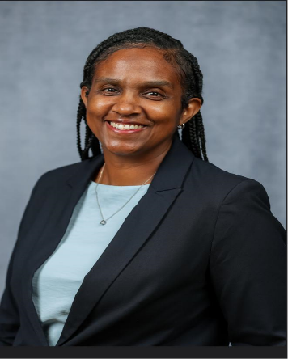
Deputy Commissioner (DCOP) Na’imah Astwood joined the Bermuda Police Service (BPS) in 1994 as a Police Cadet and later graduated from the Police Recruit Foundation Course with the Academic Award. She has worked in various departments throughout her career such as Criminal Investigations, Roads Policing, Task Force, Vulnerable Persons and Serious Crime. She has been the Commander for several international and local events and was recognized for her leadership as a Commander for The America’s Cup with a Queens Overseas Medal.
In September 2018, she was promoted to Superintendent and was posted as the Strategic Change Manager, where she led the organization in the 7-Ambitions Change Programme. During that time, she spearheaded many initiatives, such as the Parish Constable Scheme, collaborating with key stakeholders, which resulted in improvement of the working relationship between the community and the BPS.
In 2023, she was promoted to the role of Deputy Commissioner of Police, becoming the second women officer to attain this rank. She is integral in establishing processes that ensure Standards of Professional Behaviour are maintained throughout the organization. She has revamped the Officers Safety and Driver Training programs to increase the capacity, standards and accountability across the BPS. She is a certified Strategic ‘Gold Commander’ and has lead numerous nation critical incidents and events.
DCOP Astwood holds a Bachelor’s Degree in Human Management and a Post Graduate Certificate in Public Administration and Development. Additionally, she has successfully graduated from the International Commanders Course at Bramshill, U.K. and the National Academy of Federal Bureau of Investigations (FBI). In 2020, she graduated with distinction from the Strategic Command Course U.K.
DCOP Astwood has been awarded or recognized with:
- Commissioner Commendations and Awards
- ‘Women of Vision’ 100 Influential Women of Bermuda
- Queen’s Overseas Territories Police Medal
- First female to perform the role of ‘Black Rod’
- Community Achievement Award
- First Runner up in the Top Career Award in all of the Caribbean
- Senior Officer of the Year
DCOP Astwood is married with two children, and a devoted Muslim.

