2022 IAWP International Scholarship Recipient
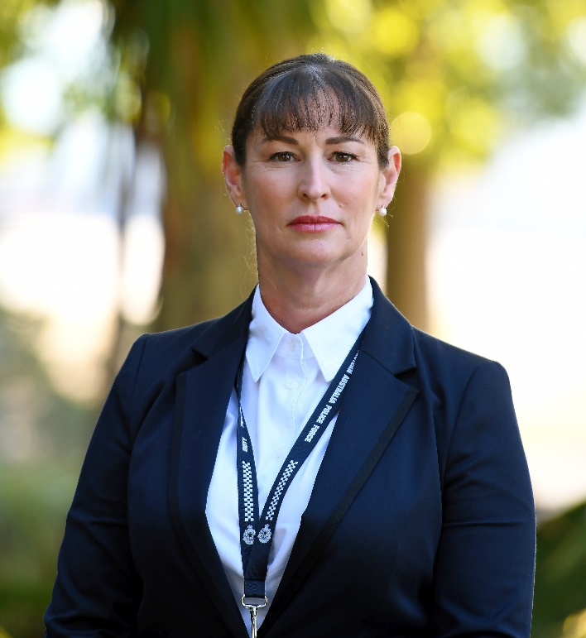
Detective Sergeant Carmel Morgan from the Western Australia Police Force was the recipient of the 2022 IAWP International Scholarship. She commenced policing in 2008 and since then has carried out a variety of roles. In 2013 she was allocated the Recidivist Family and Domestic Violence (FDV) District Manager role and while in this role resolved several long-standing files, two of which comprised numerous serious assaults against the respective male partners of two separate female perpetrators. In both incidents she identified a default setting whereby the male victim had been incorrectly identified as the perpetrator. She also noted the tendency for male victims to take the blame, due to perceived shame in being seen as a victim.
This formative experience helped shape her understanding of the perversive and complicated nature of FDV relationships and the profound effects of the offending on all parties. The successful prosecution of both offenders gave her renewed personal focus and belief in her ability to build rapport and trust with victims of crime who had lost faith in the system. Her experience working on arson and homicide squads provided her with invaluable experience regarding high level investigations, cementing her desire to become a detective.
In 2014 she completed the Detective Training Program and commenced at Gang Crime Squad, investigating Outlaw Motorcycle Gangs (OMCG) and high-level drug importation syndicates involving interstate and international targets. Sadly, five months later she was witness to her supervisor taking his own life. This experience was extremely confronting, challenging and continues to resound with her to this day. It was a tragic reminder of the importance of taking care of our own people and recognising the contribution and sacrifice of our police families.
In 2016 she took carriage of two separate historical child abuse matters, involving multiple victims over 10-year and 47-year periods respectively. These complex investigations gave her a profound insight into the nature of intergenerational child sexual abuse and the deep psychological damage inflicted on victims and their families. She forged lasting friendships with the respective victims, whose lives were fundamentally changed after finally being recognised, believed and supported.
Later that year, she was specifically tasked by Homicide detectives to assist during a suspect interview process, highlighting the rapport she had established with the main suspect, who was later convicted of homicide.
She was promoted to Sergeant in 2017 and in 2018 took up an Officer in Charge (OIC) position as the only female OIC in the District. As the first female OIC in a traditional community, she encountered sexual discrimination from her peers and the public alike. She networked with influential stakeholders in her community, implementing inclusion and support for herself and others when within my sphere of influence.
During her significant learning curve as an OIC, which included becoming a central figure in the town and a point of contact for the residents, she initiated a drug operation, targeting an entrenched drug culture which was affecting local youth. Having gained the trust of the community she fostered renewed faith in police and was successful in diplomatically changing the dynamic, setting an example of professionalism, competence and compassion.
In 2020 she was approached to take up another Sergeants role. Recognising her firm stance in challenging discrimination in all forms, she was to contribute to cultural change by addressing problematic misogyny and sexism among male staff members. She embraced the challenge, using tact and sensitivity to positively influence those around her and helped to foster genuine and sincere relationships between staff members, encouraging diversity and inclusion to support, protect and mentor female officers.
In 2021 she commenced an investigative operation targeting an established criminal network of OMCG members and foreign nationals detained at a local facility. She liaised with Gang Crime Squad (GCS) and National Anti-Gangs Squad (NAGS), building sustainable, reciprocal relationships with Australian Federal Police (AFP) and Australian Border Force (ABF).
Her next role was being allocated the Australian National Child Offender Registry (ANCOR) Local District Manager (LDM) and investigative oversight of FDV incidents for the district, liaising with the Department of Corrections, The Department of Child Protection and Sex Offender Management Squad to ensure the efficient management of all reportable child sex offenders in the district, including the intrusive management of a High Risk Serious Offender.
Latterly she completed a three-week secondment to Special Crime Squad - Serious Crime and Family Violence in Perth then in 2022 commenced her current position at Coronial Investigation Unit as the Coronial Remote Manager – Detective Supervisor. In this role she draws upon her emotional intelligence and genuine empathy when speaking with the families of deceased persons and invites her team to treat these interactions with the same level of investment and care they would afford the passing of their own family member.
Congratulations go to Carmel as the 2022 IAWP International Scholarship recipient.

